Week 2 Task: Hands-on Practice in CAD (FreeCAD)
Name: HARSH RAJ SINGH
Role: CAD Intern
Date: October 14, 2026
Software: FreeCAD 1.x (Part Design Workbench)

1. Executive Summary
This report details the successful completion of the Week 2 CAD hands-on practice exercise. Using FreeCAD's Part Design and Sketcher workbenches, a fully constrained 3D mechanical part (mounting bracket component) was developed following industry-standard parametric modeling practices. This document presents a step-by-step breakdown of the design process, feature tree structure, and the overall modeling logic applied.

2. Exercise Objectives
- Hands-on Modeling: Complete a real-world style mechanical part using FreeCAD, focusing on 2D sketching, parametric constraints, and 3D feature creation.
- Best Practices: Maintain a clean feature hierarchy, ensure fully constrained sketches, and apply proper design-for-manufacturability principles.
- Documentation: Record each stage of the modeling process and provide a clear explanation of the modeling methodology.

3. Step-by-Step Modeling Process

Step 1: Base Sketch & Geometric Constraints
- Workbench: Sketcher
- Process: Created the initial 2D outline of the base plate on the XY-plane using line and arc tools. Applied geometric constraints (coincident, horizontal/vertical, equality) along with dimensional constraints to achieve a fully constrained status (turned fully green).
- Key Details: Centered the primary geometry around the global origin to maintain symmetry for subsequent features.
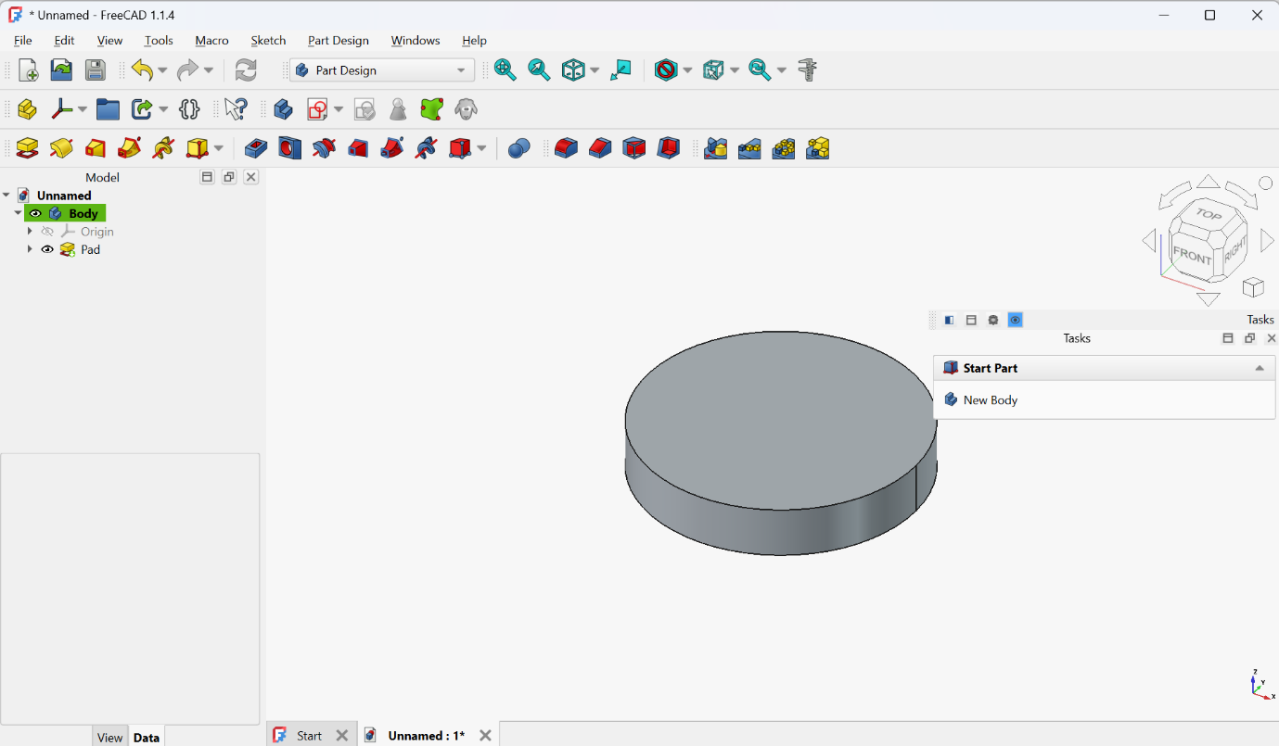

Step 2: Primary Extrusion (Pad)
- Workbench: Part Design
- Process: Applied the Pad tool to the fully constrained base sketch to generate the solid base geometry.
- Key Details: Set a uniform thickness of 15 mm, defining the foundational body of the bracket.

Step 3: Secondary Features & Pockets (Bosses and Holes)
- Workbench: Part Design
- Process: Selected top planar faces of the base pad to generate secondary sketches. Created circular profiles for mounting bosses and subtracted material using the Pocket tool for mounting holes and counterbores.
- Key Details: Applied through-all pocket operations for the bolt holes and specified depth pockets for counterbores to accommodate standard fasteners.

Step 4: Finishing Operations (Fillets and Chamfers)
- Workbench: Part Design
- Process: Applied edge fillets to internal corners to reduce stress concentration and smooth external edges for safety and aesthetics.
- Key Details: Used 3 mm radii for internal fillets and 1.5 mm chamfers on hole entries.
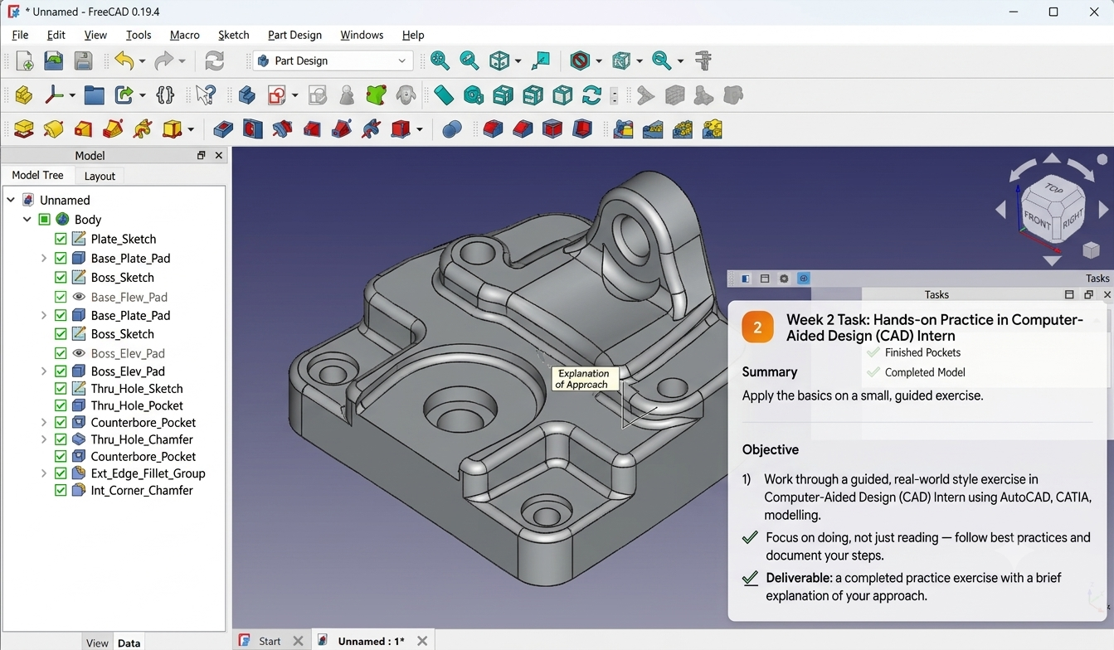

4. Model Structure & Feature Tree
The feature tree below demonstrates the sequential dependency built into the parametric model:
- Body
  - Plate_Sketch $\rightarrow$ Base_Plate_Pad
  - Boss_Sketch $\rightarrow$ Boss_Elev_Pad
  - Thru_Hole_Sketch $\rightarrow$ Thru_Hole_Pocket
  - Counterbore_Pocket
  - Ext_Edge_Fillet_Group
  - Int_Corner_Chamfer

5. Modeling Logic & Best Practices
- Fully Constrained Sketches: Every sketch was assigned sufficient geometric and dimensional constraints to prevent unintentional geometry shifts during future updates.
- Parent-Child Hierarchy: Features were ordered logically—foundational mass added first, followed by material removal (holes/pockets), and finalized with edge dress-up features (fillets/chamfers).
- Parametric Flexibility: Referencing key geometry to the origin and primary planes ensures that altering base dimensions will safely update dependent features without model errors.

6. Conclusion
The Week 2 practice exercise was successfully completed. The final model adheres to proper parametric design principles within FreeCAD, producing an accurate, easily editable 3D CAD asset.

